Digital Marketing Project 2
Social Media Content Planning

Brand Name : NIKE

Prepared By Huzaifa Ashraf

DecodeLabs – Digital Marketing Internship

SEO Analysis of Nike Website
Title Page
SEO Analysis Report
Website: Nike
Course: Digital Marketing / SEO

1. Introduction
Search Engine Optimization (SEO) is one of the most important digital marketing strategies used to improve a website's visibility on search engines such as Google, Bing, and Yahoo. Every business wants its website to appear on the first page of search results because most users click on the top-ranking websites.
Nike is one of the world's leading sportswear brands. Its website is designed with excellent SEO practices, fast loading speed, high-quality content, optimized product pages, and strong user experience.
This report analyzes Nike's website from an SEO perspective.
2. About Nike
Nike is an American multinational company that designs and manufactures sports shoes, clothing, and accessories.
Founded: 1964
Headquarters: Beaverton, Oregon, USA
Founder: Phil Knight and Bill Bowerman
Official Website: https://www.nike.com⁠�
Nike serves millions of customers worldwide and has one of the strongest online brands in the sports industry.
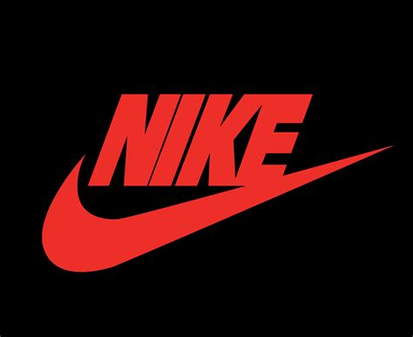

3. Nike Website Overview
Nike's website is modern, responsive, and optimized for users on desktop and mobile devices.
Main Features
Responsive Design
Secure HTTPS
Fast Loading Speed
Product Categories
Search Function
Shopping Cart
Customer Reviews
High-Quality Images
Mobile Friendly
These features improve user experience and help increase search engine rankings.
Screen shot of website is given below
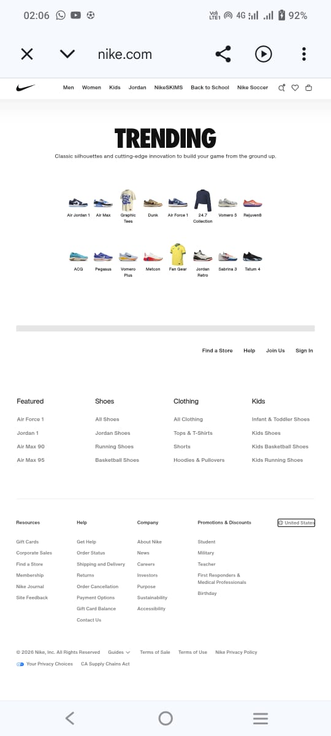
4. What is SEO?
SEO (Search Engine Optimization) is the process of improving a website so that it ranks higher in search engine results without paid advertising.
SEO helps websites receive organic traffic by improving content quality, website structure, technical performance, and authority.
Goals of SEO
Increase Website Traffic
Improve Search Rankings
Build Trust
Increase Sales
Improve User Experience
5. Importance of SEO
SEO is important because:
It brings free organic visitors.
It increases brand visibility.
It improves website credibility.
It provides better return on investment.
It helps businesses compete online.
Nike uses SEO to reach customers across different countries and languages.

6. Types of SEO
On-Page SEO
Optimizing titles, headings, keywords, images, URLs, and content.
Examples:
Optimized Product Pages
Internal Links
Alt Text
Meta Descriptions
Off-Page SEO
Activities outside the website.
Examples:
Backlinks
Social Media
Brand Mentions
Influencer Marketing
Nike has backlinks from thousands of trusted websites.
Technical SEO
Technical improvements that help search engines crawl the website.
Examples:
HTTPS
XML Sitemap
Robots.txt
Mobile Friendly Design
Fast Speed
7. How Search Engines Work

Search engines follow three major steps:
Crawling
Google bots discover website pages.
Indexing
The pages are stored in Google's database.
Ranking
Google ranks the most relevant pages based on quality, authority, and user experience.
Nike performs well because its website follows SEO best practices.
8. Keyword Research
Keyword research identifies the words people search for on Google.
Examples:
Nike Shoes
Running Shoes
Sports Shoes
Air Jordan
Nike Sneakers
Football Shoes
Gym Shoes
Basketball Shoes
Nike creates pages targeting these keywords.
9. Search Intent
Search Intent means understanding what users want.
Informational
Example:
What are Nike Air Max shoes?
Navigational
Example:
Nike Official Website
Commercial
Example:
Best Nike Running Shoes
Transactional
Example:
Buy Nike Air Force 1
Nike creates content for all four search intents.

10. Images


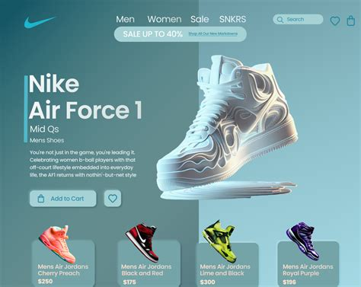

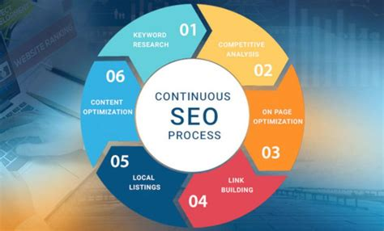
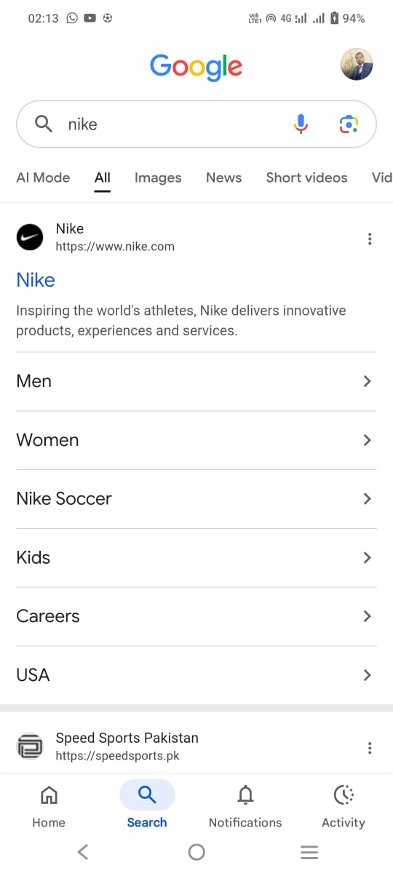
11. Summary
Nike is an excellent example of a website that successfully implements SEO strategies. Its responsive design, keyword optimization, technical SEO, and quality content help it achieve high rankings on search engines. Understanding Nike's SEO practices provides valuable insights into how businesses can improve their online visibility and attract more organic traffic.
12. Keyword Analysis
Keyword analysis is the process of researching and evaluating the words and phrases users type into search engines. It helps businesses understand customer behavior and create content according to search demand.
For a global brand like Nike, keyword optimization plays an important role in attracting customers who search for sports shoes, clothing, and accessories.
13. Importance of Keywords in SEO
Keywords help search engines understand website content.
Benefits:
Increase organic traffic
Improve search rankings
Reach the target audience
Increase product visibility
Improve conversion rates
Nike uses thousands of keywords related to sports products and lifestyle.
14. Nike Keyword Analysis
Nike targets different categories of keywords:
- Brand Keywords
These keywords include the brand name.
Examples:
- Nike
- Nike shoes
- Nike official store
- Nike sneakers
- Product Keywords
These keywords focus on products.
Examples:
- Running shoes
- Basketball shoes
- Sportswear
Training shoes
- Location-Based Keywords
Examples:
- Nike shoes USA
- Nike store near me
- Nike Pakistan

15.Primary Keywords
Primary keywords are high-value keywords that bring maximum traffic.
Examples:
Keyword Purpose
Nike shoes Main product search
Nike sneakers Product discovery
Nike running shoes Sports category
Air Jordan Famous product line
Nike clothing Apparel search
16. Secondary Keywords
Secondary keywords support main keywords.
Examples:
- Comfortable running shoes
- Best gym shoes
- Men's sports shoes
- Women's sneakers
- Athletic footwear
These keywords help Nike rank for multiple searches.
17. Long-Tail Keywords
Long-tail keywords are specific searches with lower competition.
Examples:
- Best Nike running shoes for beginners
- Nike shoes for marathon training
- Comfortable Nike shoes for daily walking
- Latest Nike Air Jordan models
These keywords attract users with buying intent.

18. 30 Keywords Analysis Table

No | Keyword | Type | Search Intent
1 | Nike | Brand | Navigational
2 | Nike shoes | Product | Transactional
3 | Nike sneakers | Product | Transactional
4 | Nike running shoes | Product | Commercial
5 | Air Jordan | Product | Commercial
6 | Nike Air Max | Product | Transactional
7 | Nike clothing | Product | Commercial
8 | Sports shoes | Generic | Informational
9 | Best running shoes | Commercial | Commercial
10 | Basketball shoes | Product | Transactional
11 | Nike football shoes | Product | Transactional
12 | Nike trainers | Product | Commercial
13 | Nike gym shoes | Product | Transactional
14 | Nike shoes for men | Product | Commercial
15 | Nike shoes for women | Product | Commercial
16 | Nike kids shoes | Product | Transactional
17 | Nike online store | Brand | Navigational
18 | Buy Nike shoes online | Purchase | Transactional
19 | Nike discount shoes | Purchase | Transactional
20 | Nike new collection | Product | Commercial
21 | Nike lifestyle shoes | Product | Commercial
22 | Nike basketball sneakers | Product | Transactional
23 | Nike workout clothes | Product | Commercial
24 | Nike sportswear | Product | Commercial
25 | Nike footwear | Product | Informational
26 | Comfortable Nike shoes | Long Tail | Commercial
27 | Nike shoes size guide | Informational | Informational
28 | Nike shoe review | Informational | Informational
29 | Latest Nike shoes | Commercial | Commercial
30 | Original Nike shoes | Purchase | Transactional

19. Keyword Intent Analysis
- Informational Keywords
Users want information.
Examples:
- Nike shoe review
- Nike size guide

- Commercial Keywords
Users are comparing products.
Examples:
- Best Nike running shoes

- Transactional Keywords
Users want to buy.
Examples:
- Buy Nike shoes online
- Navigational Keywords
Users search for a specific website.
Example:
- Nike official website
20. Competitor Analysis
Nike competes with several major sports brands.
Main competitors:
- Adidas
- Puma
- Under Armour
- New Balance
21. Competitor Comparison Table
Brand | SEO Strength | Main Keywords | Content Strategy
Nike | Very Strong | Shoes, Sportswear, Jordan | Products + Stories
Adidas | Strong | Running Shoes, Sneakers | Campaign Content
Puma | Medium | Sports Shoes | Lifestyle Marketing
Under Armour | Medium | Training Gear | Fitness Content
New Balance | Strong | Comfort Shoes | Product Reviews

22. Nike SEO Strengths
- Strong Brand Authority

Nike has millions of backlinks from trusted websites.
- Quality Content
Nike publishes:
- Product stories
- Athlete campaigns
- Training content

- User Experience
The website provides:
- Easy navigation
- Fast search
- Mobile optimization
23. Nike SEO Weaknesses
Some possible improvements:
- More educational blog content
- More localized content for different countries
- More user-generated content
24. Summary
Keyword analysis shows that Nike successfully targets brand, product, and transactional keywords. Its strong brand authority, optimized product pages, and competitive SEO strategy help it maintain a leading position in the sportswear industry.
Competitor analysis shows that Nike remains one of the strongest brands due to its global recognition, digital marketing campaigns, and effective SEO implementation.

Content Strategy, On-Page SEO & Final Analysis of Nike Website
25. Introduction
Content strategy and on-page SEO are important parts of search engine optimization. A successful website needs high-quality content, optimized pages, proper keywords, and a user-friendly structure.
Nike uses a strong digital content strategy to attract customers, increase brand awareness, and improve search engine visibility.
26. Nike Content Strategy
Nike's content strategy focuses on combining product marketing with storytelling.
The brand does not only sell shoes and clothing but also creates emotional connections with customers.
Main Goals of Nike Content Strategy:
- Increase brand awareness
- Promote products
- Build customer trust
- Improve organic traffic
- Encourage customer engagement
27. Types of Content Used by Nike
1. Product Content
Nike creates detailed product pages containing:
- Product names
- Descriptions
- Images
- Specifications
- Size information
- Customer reviews
Example:
Nike Air Jordan product pages.
2. Video Content
Nike uses videos for:
- Product launches
- Athlete stories
- Training guides
- Advertisements
Videos increase engagement and time spent on the website.
3. Blog and Story Content
Nike publishes inspirational content related to:
- Athletes
- Sports events
- Fitness
- Innovation
This helps attract informational searches.
4. Social Media Content
Nike uses:
- Instagram
- YouTube
- Facebook
- TikTok
Social media improves brand visibility and generates website traffic.
28. Content Optimization Techniques
Nike improves content through:
1.Keyword Optimization
Using relevant keywords naturally.
Examples:
- Running shoes
- Sportswear
- Basketball shoes
2. High-Quality Images
Product images improve user experience and conversions.
3.Clear Headings
Using proper H1, H2, and H3 headings.
4.Mobile-Friendly Content
Content is optimized for mobile users.
29. Meta Tags Analysis
Meta tags provide information about a webpage to search engines.
Title Tag
Example:
Nike Official Website. Nike Shoes, Clothing & Accessories
Benefits:
- Improves ranking
- Increases click-through rate
Meta Description
Example:
"Explore the latest Nike shoes, clothing and sports products designed for athletes and everyday lifestyle."
Benefits:
- Gives users page information
- Improves search appearance
Header Tags
Nike uses:
- H1 for main page title
- H2 for categories
- H3 for product sections
This improves content structure.
30. On-Page SEO Analysis
On-page SEO includes optimization inside the website.
1. URL Optimization
Nike uses clean URLs.
Example:
Nike.com product pages have understandable URLs.
2. Keyword Placement
Keywords are placed in:
- Titles
- Headings
- Product descriptions
- Image alt text
3. Image SEO
Nike optimizes images through:
- Descriptive file names
- Alt text
- Proper size
- High quality
4. Internal Linking
Nike connects related pages.
Examples:
Shoes category → Running shoes
Product page → Related products
This helps search engines understand website structure.
31. Technical SEO Factors
Nike website includes:
HTTPS Security
Protects user information.

Mobile Optimization
Works properly on smartphones and tablets.
Fast Loading Speed
Improves user experience and ranking.
XML Sitemap
Helps search engines discover pages.
Structured Data
Helps search engines understand products.
32. User Experience (UX) Analysis
Nike provides excellent user experience through:
- Simple navigation
- Search feature
- Product filters
- Easy checkout process
- Responsive design
Good UX improves SEO performance because users spend more time on the website.
33. SEO Recommendations for Nike
Although Nike has strong SEO, some improvements can be made:
1. Increase Blog Content
More educational articles can attract informational traffic.
Examples:
- How to choose running shoes
- Benefits of sports training shoes
2. Local SEO Improvement
Create more location-specific pages for different countries.
3. More User Reviews
Customer-generated content can improve trust.
4. Voice Search Optimization
Optimize content for voice-based searches.
34. Conclusion
Nike is one of the strongest examples of successful SEO implementation. The company's website uses effective keyword targeting, high-quality content, technical SEO, and excellent user experience.
Nike's strong brand authority and digital marketing strategies help it achieve high visibility in search engines.
The analysis shows that SEO is not only about rankings but also about providing valuable content and a better experience for users.
11. References
Nike Official Website
https://www.nike.com⁠
Google Search Central
https://developers.google.com/search⁠
Moz SEO Learning Center
https://moz.com/learn/seo⁠
Search Engine Journal – SEO Resources
https://www.searchenginejournal.com⁠
Ahrefs SEO Blog
https://ahrefs.com/blog⁠

